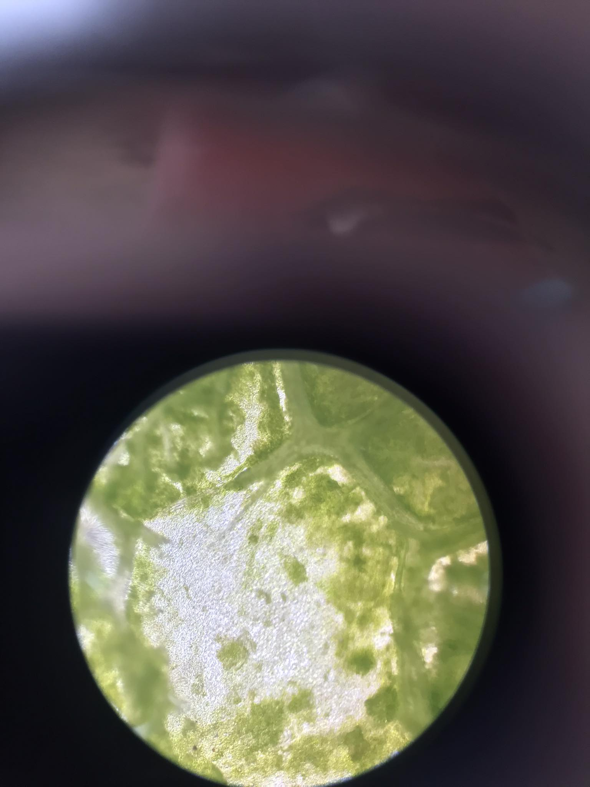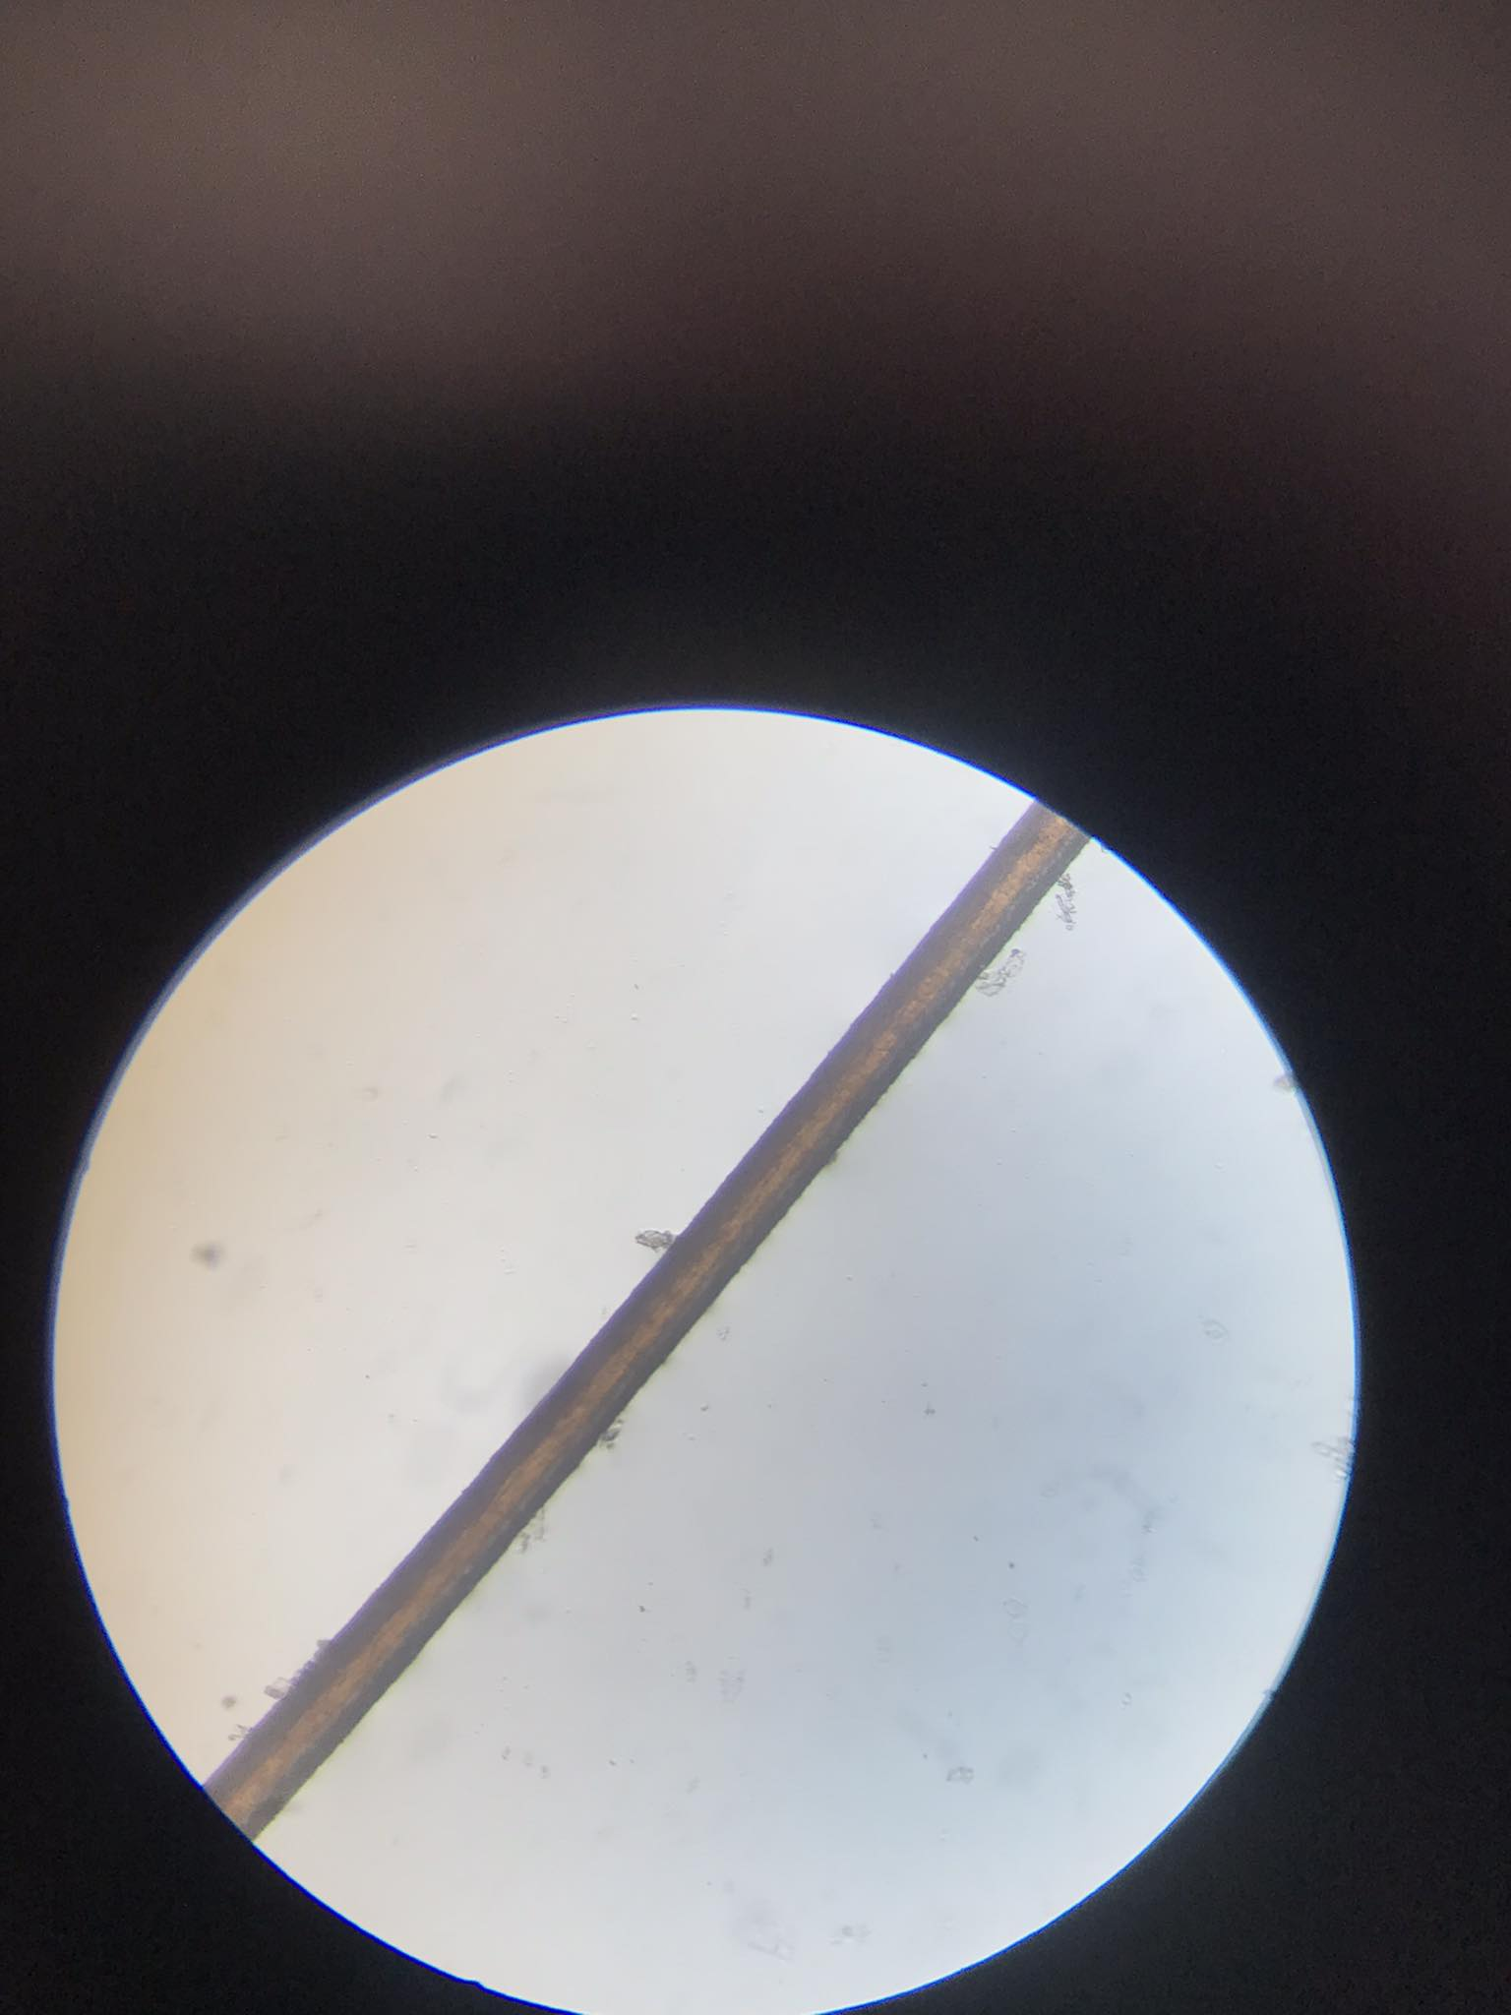

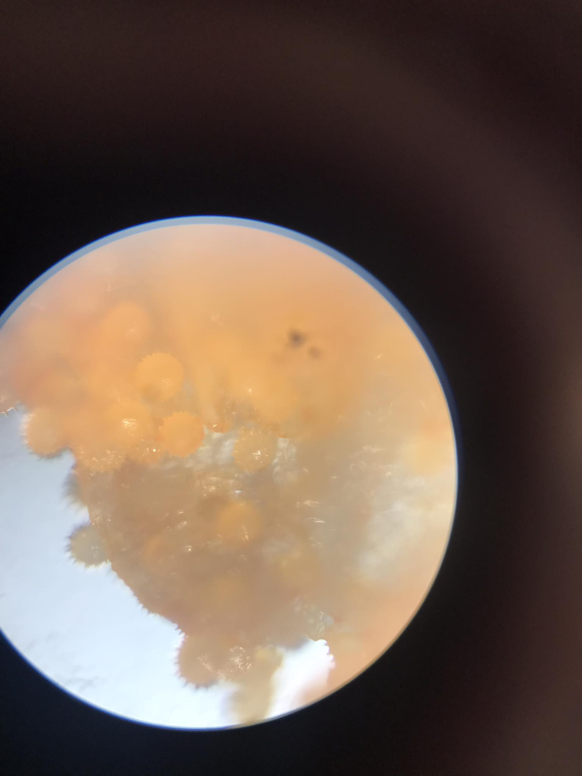

fly wings

gumamela petal

doble kara leaf

mango leaf

san francisco leaf

ant

gumamela pollen

hair strand

cheek cell

onion

